Role of Services In Banking Sector

By : Juhi Sawlani
Designation : Assistant Professor
Subject: Service Relationship Marketing
N. R. Vekariya Institute Of Business Management Studies, Bilkha Road, Junagadh – 362001
Phone : 8905636444
E – mail :jssawlani@gmail.com
Abstract:

A bank is a financial intermediary that accepts deposits and channels those deposits into lending activities. They are the active players in financial market. The essential role of a bank is to connect those who have capital with those who seek capital. It is necessary to encourage people to deposit their surplus funds with the banks. These funds are used for providing loans to the industries thereby making productive investments.

With the potential to become the 5th largest banking industry in the world by 2020 and the 3rd largest by 2025 according to KPMG-CII report, India’s banking and financial sector is expanding rapidly. The Indian Banking industry is currently worth Rs.81 trillion (US $ 1.31 trillion) and banks are now utilizing the latest technologies like internet and mobile devices to carry out transactions and communicate with the masses.

The Indian banking sector consists of 26 public sector banks, 20 private sector banks and 43 foreign banks along with 61 regional rural banks (RRBs) and more than 90,000 credit cooperatives.

Key Words:Banking Sector, RBI, Mobile Banking, Internet Banking.
About The Banking Sector In India:
HISTORY AND DEVELOPMENT :

Banking in India originated in the 18th century. The oldest bank in existence in India is the State Bank of India, a government-owned bank in 1806. SBI is the largest commercial bank in the country.The first bank in India, was established in 1786. The journey of Indian Banking System can be segregated into three distinct phases as follows :

THE JOURNEY OF INDIAN BANKING SYSTEM

- PHASE 1 : Early Phase (1786 - 1949) :

Bank of India was set up in the year 1786. Next came Bank of Hindustan and Bengal Bank. The East India Company established Imperial Bank of India in 1921 as private shareholders banks. In 1865, Allahabad Bank was established and first time exclusively by Indians, Punjab National Bank Ltd. was set up in 1894. Between 1885 and 1913, Bank of India, Central Bank of India, Bank of Baroda, Canara Bank, Indian Bank, and Bank of Mysore were set up. Reserve Bank of India came in 1935. There were approximately 1100 banks. To simplify the functioning and activities of commercial banks, the Government of India came up with the Banking Regulation Act, 1949. Reserve Bank of India was vested with extensive power for the supervision of banking in India as the Central Banking Authority.

During those days, public had lesser confidence in the banks and the growth of banks was low. The savings facility provided by the Postal department was comparatively safer. Moreover, funds were largely given to traders.

- PHASE 2 : Nationalization Of Indian Banks (Up to 1991) :

The Reserve Bank of India was nationalized in 1949 and was empowered to regulate, control, and inspect the banks in India. The government formed State Bank of India to act as the principal agent of RBI and to handle banking transactions of the Union and State Governments all over the country. 7 banks forming subsidiary of State Bank of India were nationalized in 1959. In 1969, major process of nationalization was carried out with the effort of the then Prime Minister of India, Mrs. Indira Gandhi and 14 major commercial banks werenationalized which contained 85% of bank deposits in the country.2ndphase of nationalization was carried out in 1980 with 6 more banks wherethe Government controlled around 91% of the banking business of India.

After the nationalization, the branches of the public sector banks in India rose to approximately 800% and deposits and advances took a huge jump by 11,000%.Banking in the sunshine of Government ownership gave the public implicit faith and immense confidence about the sustainability of these institutions.

- PHASE 3 : Liberalization Of Indian Banks (After 1991) :

In the early 1990s, the government embarked on a policy of liberalization, licensing a small number of private banks. These came to be known as New Generation tech-savvy banks and included UTI Bank (since renamed Axis Bank), ICICI Bank and HDFC Bank. This move, along with the rapid growth in the economy of India, revitalized the banking sector in India. It proposed relaxation in the norms for foreign direct investment which has gone up to 74% with some restrictions.The country is flooded with foreign banks and their ATM stations.

This phase has introduced many more products and facilities in the banking sector in its reforms measure. Efforts are being made to give a satisfactory service to customers. Phone banking and net banking is introduced. The entire system became more convenient and swift.The new wave ushered in a modern outlook and tech-savvy methods of working for traditional banks. All this led to the retail boom in India. People demanded more from their banks and received more.Time is given more importance than money.
STRUCTURE OF THE INDIAN BANKING SYSTEM :

- Public Sector Banks include Allahabad Bank, Bank of India, Bank of Baroda, Dena Bank, UCO Bank, IDBI Bank, SBI, etc.
- Private Sector Banks include HDFC Bank, Axis Bank, Kotak Mahindra Bank, ING Vyasa Bank, YES Bank, ICICI Bank, Indusland Bank, etc.
- Foreign Banks include HSBS Bank, JPMorgan Chase Bank, Standard Chartered, Citibank, Barclays Bank, etc.
- The apex body for regional rural banks is NABARD which is for agriculture and rural development.

BANKING SECTOR’S CONTRIBUTION TO THE ECONOMY :

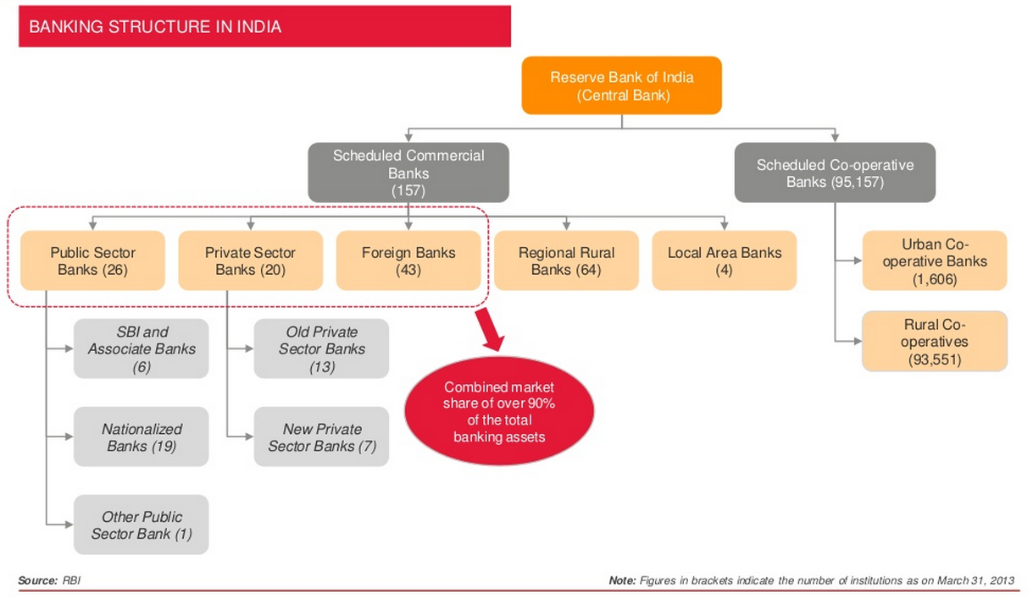
- Total banking assets in India touched US$ 1.8 trillion in FY13 and are anticipated to cross US$ 28.5 trillion in FY25.
- Bank deposits have grown at a rate of 21.2% over FY 06 – 13.
- Aggregate deposits of all Scheduled Commercial Banks (SCBs), as a % of GDP increased from 61% in FY 07 to 67% in FY 13, driven by increasing demand from retail customers.
- Banking stands 2nd in terms of employment (average share of 28%). The banking sector is projected to create up to 2 million new jobs in the next 5-10 years.

Effectiveness Of Services In Banking Sector :

Banks offer a large number of products and services across retail, wholesale and treasury segments. They are as follows :

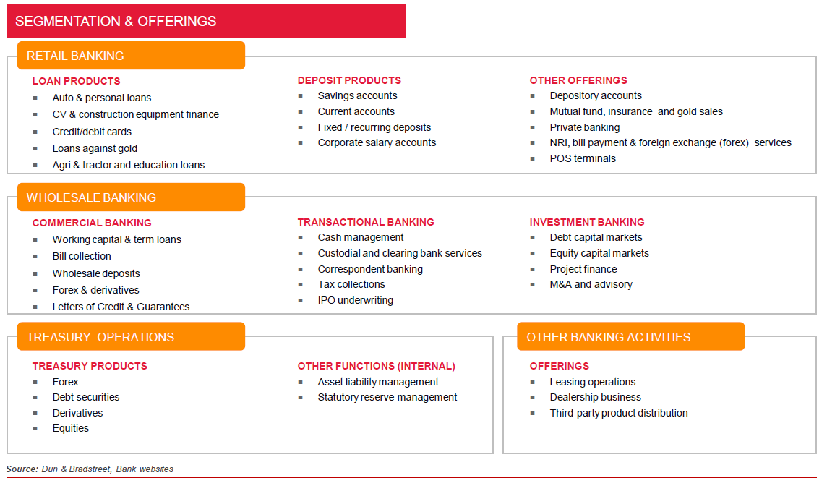
- Retail Banking :

Retail banking is when a bank executes transactions directly with consumers, rather than corporations or other banks. Services include savings and transactional accounts, mortgages, personal loans, debit cards, and credit cards. The term is generally used to distinguish these banking services from investment banking, commercial banking orwholesale banking. It may also be used to refer to a division of a bank dealing with retail customers and can also be termed as Personal Banking services.
- Wholesale Banking :
Wholesale banking is the provision of services by banks to organizations such as Mortgage Brokers, large corporate clients, mid-sized companies, real estate developers and investors, international trade finance businesses, institutional customers (such as pension funds and government entities/agencies), and services offered to other banks or other financial institutions.Modern wholesale banks are engaged in finance wholesaling, underwriting, market making, consultancy, mergers and acquisitions, fund management, etc.
- Treasury Operations :
Treasury Operations include management of an enterprise's holdings, with the ultimate goal of maximizing the firm's liquidity andmodifying its operational, financial and reputational risk. Treasury Management includes a firm's collections, disbursements, concentration, investment and funding activities. In larger firms, it may also include trading in bonds, currencies, financial derivatives and the associated financial risk management.Most banks have whole departments devoted to treasury management and supporting their clients' needs in this area.

Traditional Services Offered By Banks :
- Savings Deposits
- Currency Exchange
- Business Or Personal Loans
- Safekeeping Of Valuables
- Offering Financial Services For A Fee

New Services Offered By Banks
- Financial Advising
- Credit, Debit And Gift Cards
- Cash Management
- Equipment Leasing
- Venture Capital Loans And Private Equity Funds
- Insurance Services
- Retirement Plans
- Equity Trading And Investment Services
- Mutual Funds And Annuities
- Investment Banking
- Wealth Management

-: CURRENT SCENARIO OF SERVICES IN BANKING SECTOR :-

Banking today is a flourishing industry, focused on technological innovation. Internet banking has emerged as the biggest focus area in the “Digital Transformation” agenda of banks. Some of the latest services provided by banks are as follows :
1. Net Banking Services.
2. Tele Banking Services.
3. Mobile Banking Facilities
4. Credit And Debit Card Services.
5. ATMs
6. SMS Alert Services.
Internet Banking:
Internet banking refers to the use of the Internet as remotedelivery channel for banking services. Such services includetraditional ones, such as opening a deposit account or transferring funds, among different accounts, and new banking services, such as electronic bill payment, allowing customers to receive and pay bills via a bank’s website. It has the added benefit of making cross – border transactions easy. With online banking, you won’t ever have to worry about full access to your account. You’ll have quick and easy 24-hour access from anywhere in the world. Also online banking services often offer higher interest rates with their savings accounts.

Mobile Banking:
Mobile banking is a term used for performing balance checks, account transactions, payments etc. via a mobile device suchas a mobile phone. Mobile banking today is most often performed via SMS or the Mobile Internet but can also use special programs downloaded to the mobile device. It provides you with alerts on account activity or passing of threshold, payments and transfers, real – time investment quotes, ATM location, etc.Banksareincreasinglyadoptingmobile-basedchannelsasdeliverychannelstoexpandreachandlower costs sinceopeningbankbranchescomeswithitsassociatedregulatoryandfinancialrestrictions.Inrecentyears,themobilebankinghasbeenreflectingagrowingtrendwiththevolumeandvalueincreasingby108.5% and228.9%, respectively.
ATM:
ATM is a computerized telecommunications device that provides the customers of a financial institution with access to financial transactions in a public space without the need for a human clerk or bank teller. Security is provided by the customer by entering a personal identification number (PIN). ATMs make the basic functions of deposit and withdrawal easily available to the customer.
Telephone Banking :
Telephone banking is a service provided by a financial institution which allows its customers to perform transactions over the telephone. Most telephone banking uses an automated phone answering system with phone keypad response or voice recognition capability. To guarantee security, the customer must first authenticate through a numeric or verbal password or through security questions asked by a live representative. With the exception of cash withdrawals and deposits, it offers virtually all the features of an ATM: account balance information and list of latest transactions, electronic bill payments, funds transfers between a customer's accounts, etc. Usually, customers can also speak to a live representative located in a call centre or a branch, although this feature is not guaranteed to be offered 24/7. In addition to the self-service transactions, telephone banking representatives are usually trained to do what was traditionally available only at the branch: loan applications, investment purchases and redemptions, cheque book orders, debit card replacements, change of address, etc.
Conclusion:
Internet Banking versus Traditional Methods
In spite of so many facilities that Internet banking offers us, we still seem to trust our traditional method of banking and is reluctant to use online banking. But here are few cases where Internet banking will turn out to be a better option in terms of saving your money :
- Virtual banking has the advantage of having a lower cost of handling a transaction via the virtual resource compared to the cost of handling the transaction via the branch.
- ‘Stop payment’ done through Internet banking will not cost any extra fees but when done through the branch, the bank may charge you Rs.50 per cheque plus the service tax.
- Through Internet banking, you can check your transactions at any time of the day, and as many times as you want to.On the other hand, in a traditional method, you get quarterly statements from the bank and if you request for a statement at your required time, it may turn out to be an expensive affair. The branch may charge you Rs.25 per page, which includes only 30 transactions. Moreover, the bank branch would take eight days to deliver it at your doorstep.
- If the fund transfer has to be made outstation, where the bank does not have a branch, the bank would demand outstation charges. Whereas with the help of online banking, it will be absolutely free for you.
- In the last decade, India has seen a shift from traditional payment methods, i.e., cash/paper-based payments to modern electronic payment systems. However, 97% of payment transactions for public sector banks are paper based as compared to 60% for private sector banks.

References:
http://en.wikipedia.org/wiki/Banking_in_India
http://www.yourarticlelibrary.com/banking/the-structure-of-banking-system-in-india-explained/7530/
http://www.yourarticlelibrary.com/banking/indian-banking-system-structure-and-other-details-with-diagrams/23495/
http://www.yourarticlelibrary.com/banking/e-banking-in-india-services-available-in-e-banking-and-its-practical-uses/23498/
http://www.yourarticlelibrary.com/essay/virtual-banking-system-in-india/26337/
https://www.scribd.com/doc/39727210/13/DIFFERENCE-BETWEEN-TRADITIONAL-AND-E-BANKING

